**Public Speaking**

It is defined as the art of appearing in front of an audience facing the audience, presenting your speech and making them understand what you want them to understand within the limited time and resources given to you.

It is used to address a large number of people to inform, create awareness, persuade, or provide solutions.

There can be different forms of public like:

* Short talks /Presentations.
  + Short talk is a small informal communication between two persons.
  + Providing information on a particular topic using slides.
* Discussions/Group discussions.
  + Group Discussion or GD is a type of discussion that involves people sharing ideas or activities.
* Meetings
  + two or more people come together to converse about a topic or agenda.
* Briefings/ Instructions.
  + A briefing is a meeting at which information or instructions are given to people, especially before they do something.
  + detailed information about how something should be done or operated.
* Debate.
  + Discussion in which people express their opinions.
* Seminars.
  + A seminar is a form of academic instruction, either at an academic institution or offered by a commercial or professional organization.

Delivery Of Speech

There are different ways that people use to deliver the speech. Different people may choose a different way to deliver a speech as per their preference and convenience. But each have their own advantages and these advantages. You must choose the delivery of speech appropriate for a public speech. Elocution and presentation, keeping in mind the advantages and disadvantages so as to make it more effective.

1.Memorization:Write down your speech and read it several times to memorize it, and then speak in front of the audience from your memory. In this type of delivered your speech, you don’t keep a paper with you containing your speech or brief notes.

Advantages:

* As you have memorized you will not leave out any point.
* There is a very high scope of high contact and gestures.
* If you have memorized it well, you also look very natural.

Disadvantages:

* When you speak something from your memory, there is a very high risk of forgetting a point suddenly, and you will have to try very hard to remember it, or sometimes skip the point and go to the next one.
* Some people who are not very good in memorizing may fumble a lot, and it will take away the natural effect.
* There is no flexibility. example, if a person from audience asks a question in between, you may forget where you left, and it becomes difficult to continue fluently.

2.Manuscript:

Write your complete speech and carry it with you to read out word to word from the script.

Advantages:

* As you are going to read out everything, you will not miss out any point.
* This method is appropriate for people who are very good readers and can add paralinguistics while reading.
* The speech will be perfect, and there won’t be any fumbling.
* Flexibility is there, as you can always start from the point where you left, even if you are interrupted.
* While using this method, you are more confident as you don’t have any fear of forgetting..

Disadvantages:

* If you are not a good reader, the entire speech will be very monotonous and unnatural.
* It sometimes becomes very boring for the audience when a person just reads out from a paper.
* The audience may not trust on what you are saying, as it may look like your original thoughts.
* The scope of eye contact and gestures is minimum.

3.Impromptu:

Sometimes you may have to deliver a speech without any preparation. For example, when you are asked to give a speech on a farewell of your colleague, you have to speak on the spot. This is called impromptu.

Advantages:

* It is highly natural and original, as you are speaking, what you think.
* Scope of eye contact and gestures is maximum.
* There’s a lot of flexibility as it can be as interactive as possible.
* More parallel linguistics can be used.

Disadvantages:

* Biggest disadvantage is that, if your knowledge About the topic is not sufficient you will fumble.
* Sometimes you may have to give long poses to think what to say, which may leave the audience irritated.
* There is no editing time. And so the arrangement of ideas may be a haphazard, losing out the continuity in thoughts.

4. Notes: Taking note with you while delivering a speech is the most popular method. This method uses the advantages of memorization and manuscript method. It also allows the impromptu thoughts to be included in this method. You take a note along which has only main points to be covered, written in sequence. You first prepare the whole speech several times while delivering the speech. You speak without seeing the notes. But if required, you just make a glance into the nodes to check the sequence, or the points you are supposed to speak on a particular point.

Advantages:

* Tera new chances of forgetting any point as you have the notes written in a sequence.
* It gives more flexibility and can be interactive.
* Scope of eye contact and gestures is more.
* It looks natural and interesting.
* There are no disadvantages of this method. If you are well prepared, but if you haven’t done enough preparation, then any method will fail in making your speech effective.

Barrier to speaking:

1. Physical Barrier:

~ loud Environment

1. Perceptual barriers :

~These are internal. If you go into a situation thinking that the person you are talking to isn't going to understand or be interested in what you have to say, you may end up subconsciously sabotaging your effort to make your point. You will employ language that is sarcastic, dismissive, or even obtuse, thereby alienating your conversational partner.

1. Interpersonal barrier:

* **Desire to Participate -** The lack of desire to participate in the communication process is a significant barrier. There is nothing more frustrating than trying to communicate with an individual that clearly does not want to.
* **Desire to Explore -** Unwillingness to explore different ideas, opinions, and priorities create communication barriers every day of our lives. A clear lack of desire to explore your views, opinions, or ideas can be extremely frustrating.

1. Cultural barrier:

~A Cultural barrier in communication occurs mainly when communication happens between two different cultural backgrounds.

1. Language barrier:

Language barriers usually occur when two people who speak different languages cannot understand one another, and there is a breakdown in language and communication.

1. Gender Barrier:

Gender barriers to communication arise because men and women have a different way of communication and each feels uncomfortable while talking to the other because of the basic differences in communication styles.

1. Emotional Barrier:

An emotional barrier to communication is a mental limitation that prevents you from openly communicating your thoughts and feelings.

How to be good public speaker??

Practice in front of the mirror:

Deliberate practice will boost your confidence to speak in front of people. You can practice by talking in front of a mirror or with your close member.

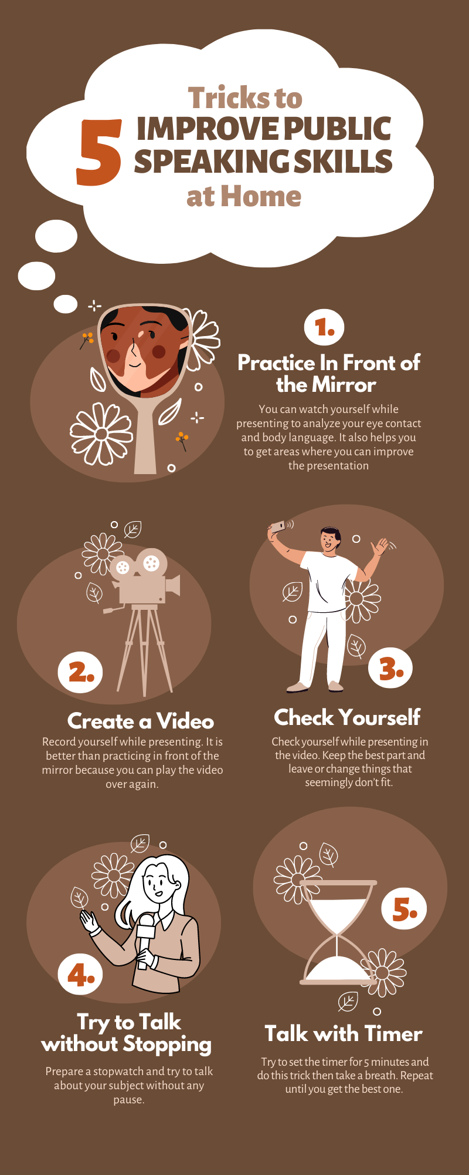

Utilize visual aid:

In more formal speaking situations, public speakers often use visual aids to help give a more effective presentation. For example, high lighting your key points in a presentation slideshow is a great way to help your audience remember those points.

Know your audience:

Check your audience and learn about them. Ensure you know their background, things they often talk about, and even jokes they love.

Dos and Donts:

